

Counterterrorism Efficacy Across Political Regimes: The Authoritarian Advantage in Comparative Perspective

**Abstract:**

This paper critically examines the comparative effectiveness of counterterrorism strategies in authoritarian regimes vis-à-vis their democratic counterparts. It interrogates the mechanisms underlying authoritarian success in eliminating terrorism, specifically, the centralisation of power and decision-making, stringent control over information and populace, and willingness to employ repressive measures. Leveraging a rigorous research design, this study integrates in-depth case studies and empirical data analysis, supplemented by a comprehensive survey, to substantiate the argument that authoritarian regimes may have a comparative advantage in combating terrorism. However, the findings also spotlight the significant trade-offs between security and civil liberties, emphasising the nuanced understanding and acceptance of such trade-offs by the populace, as revealed by the survey. The paper underscores the importance of counterterrorism strategies that holistically consider both security and human rights concerns, advocating for a balanced approach that upholds societal security without eroding civil liberties. By exploring these intersections, this study contributes to the broader discourse on global counterterrorism efforts, emphasising the necessity for governments to foster trust and cooperation with their citizens, tackle the root causes of terrorism, and conduct transparent and inclusive policy debates for sustainable, ethical, and effective counterterrorism.

Antonio Verdi Walbaum

IE University, Madrid

**Introduction:** The central argument of this comparative thesis is that, within the specific context of combating terrorism and not for pursuing unrelated political objectives or consolidating power, authoritarian regimes offer a more effective approach than democratic governments to counterterrorism due to their ability to implement security measures quickly and efficiently without bureaucratic delays, and exercising power without checks and balances, similar to how terrorists operate. While acknowledging the potential restriction of civil liberties, human rights violations, and collateral damage associated with these regimes, the benefits of this strategy, such as the prevention of terrorist attacks and the protection of the population, outweigh the associated costs in the long run, as the number of casualties would be lower and terrorism would vanish faster. To support this claim, the essay will review existing literature, examine, and compare specific historical cases of authoritarian regimes that have implemented effective security measures upholding ceteris paribus presumption, enabling the control of extraneous variables that could affect the outcomes, and analyse relevant empirical data, such as terrorism statistics and comparative analyses of democratic and authoritarian regimes. The research will also incorporate insights from a survey conducted to gather public perception on these issues, adding a layer of public opinion to the empirical and historical data. Additionally, this work will critically address arguments against authoritarian regimes and consider potential counterarguments to this approach. The essay ultimately seeks to provide a comprehensive understanding of the advantages of authoritarian counterterrorism measures, to contribute to the ongoing debate on the most effective strategies for tackling this global challenge.

The diverse nature of terrorist organisations and their motivations has led to a debate on the most effective counterterrorism strategies. As democratic and authoritarian regimes implement different approaches to combating terrorism, it becomes crucial to evaluate their effectiveness. Terrorism has both human and material devastating consequences, which is why governments must implement urgent measures to combat it. However, these measures can risk the democratic principles of a country, which presents a significant ethical dilemma on which would be the most appropriate course of action.

**Definition and characteristics of authoritarian regimes:** An authoritarian regime is a political system in which a small group of leaders or a single leader wields unchecked power over the state. These regimes typically operate with limited political and social freedoms, a controlled media landscape, a lack of checks and balances and often relies on violence and repression to impose their agenda. The primary goal of authoritarian regimes is often maintaining stability and control of their status quo, which leads them to prioritise security and suppress any form of resistance or dissent. Authoritarianism comes in various forms, including military dictatorships, absolute monarchies, and one-party states but they all have a centralised power structure.

**Comparison of democratic and authoritarian approaches:** Democratic and authoritarian regimes differ significantly in their approaches to implementing counterterrorism strategies. Democratic societies tend to prioritise the rule of law, human rights, and civil liberties which is why they might be perceived as too lenient or indecisive. As is a bureaucratised system, democratic governments also involve more extensive checks and balances, which can slow down decision-making and implementation of counterterrorism measures. Conversely, authoritarian regimes can act quickly and decisively in the face of terrorist threats, as their centralised power structure allows for rapid decision-making and implementation of security measures when facing crises.

To further elaborate on these arguments, it is essential to delve into various theories concerning the utilisation of an authoritarian approach in combating terrorism. This discussion will involve an examination of the potential benefits and disadvantages associated with such an approach.

**Rapid and efficient implementation of security measures:** The ability of an authoritarian regime to implement security measures rapidly and efficiently is one of its main advantages. Unlike democratic systems, authoritarian regimes are not restricted by regulations or institutions, allowing them to respond effectively to terrorist threats. This is particularly important in urgent situations that require decisive action. Thanks to their centralised power structure and streamlined decision-making processes, authoritarian regimes can enact necessary policies without bureaucratic delays. This timely action can be critical in preventing terrorist attacks and disrupting terrorist networks.

**Swift response to national security threats:** Authoritarian regimes prioritise national security and are more prepared to address potential threats. Their strong emphasis on maintaining things under control enables them to allocate significant resources to intelligence gathering, surveillance, and law enforcement. These extensive measures are essential to detect and intervene in terrorist plots before they can be carried out. This proactive approach to national security allows authoritarian regimes to take preemptive measures, consequently reducing the likelihood of successful terrorist attacks and ensuring the protection of their citizens. By dedicating substantial resources to counterterrorism efforts, authoritarian regimes can create a robust and vigilant security apparatus, better equipped to identify and neutralise threats promptly.

**Focus on stability and control:** The primary goal of authoritarian regimes is to maintain stability and control, taking a firm and unwavering position against terrorism, where the focus is on completely eradicating it. This position can result in the development and implementation of integral counterterrorism strategies that address the root causes of terrorism and prevent the radicalisation of potential terrorists. By prioritising stability and control, authoritarian regimes can create an environment that is less conducive to the growth and spread of terrorism.

**Countervailing power:** To effectively combat terrorism, the state must possess sufficient power to confront terrorist groups on equal footing. As terrorists operate outside of the legal framework, they are not subject to the same constraints as the state and can act with impunity. Therefore, the state must be willing and able to use similar measures to countervail the power of terrorism, including the use of force if necessary. However, it is crucial to ensure that the use of extreme measures is proportionate to the threat posed by terrorism.

**Fewer deaths in the long run:** Often, authoritarian regimes must make difficult decisions that involve the unfortunate consequence of killing innocent civilians. This study argues that adopting an authoritarian regime can lead to the faster eradication of terrorism, ultimately resulting in fewer deaths in the long term, even if it means sacrificing the lives of innocent civilians that seemed to be potential threats during the process. The rationale behind this argument is that if terrorism persists for an extended period, more innocent people will be killed over time, leading to a higher mortality rate. Acknowledging the controversial nature of this stance, this paper argues that it is preferable to be responsible for the deaths of a limited number of civilians in the fight against terrorism, rather than allowing innocent people to die every day for an indeterminate period due to ongoing terrorist activities.

**Evaluation of authoritarian strategies:** While authoritarian regimes can demonstrate short-term effectiveness in combating terrorism, the long-term implications of their methods must be considered. The trade-offs between security and human rights, civil liberties, and social stability are complex and depend on the context of each nation. However, the potential negative consequences of these trade-offs should not be ignored in evaluating the overall effectiveness of authoritarian counterterrorism strategies.

**Restriction of civil liberties:** Authoritarian counterterrorism measures often involve the restriction of civil liberties, such as freedom of speech, assembly, and the press. These limitations can reduce government accountability and create a climate of fear among the population.

**Violation of human rights:** The implementation of strict security measures in authoritarian regimes frequently results in human rights violations, including illegal detentions, tortures, and extrajudicial killings. These abuses can damage a country's international reputation and worsen social issues.

**Collateral damage:** The authoritarian approach may cause collateral damage, both in terms of civilian casualties and the destruction of infrastructure. This damage can create more division and anger within the affected communities and increase resentment towards the government which creates conditions that foster terrorism in the long-run.

**Acknowledging the drawbacks:** Despite the considerable challenges posed by the restriction of civil liberties, human rights violations, and collateral damage, this study argues that the benefits of reestablishing peace and stability through authoritarian counterterrorism measures are worth the sacrifices. People are generally more fearful of terrorism and the chaos it creates than they are of their governments (See Appendix A).

However, this paper´s support for authoritarian regimes is limited to the specific context of combating terrorism and should not be extended to other aspects of governance. The use of authoritarian measures should not be exploited as a pretext for pursuing unrelated political objectives or consolidating power. Instead, they should be employed solely to counter terrorism effectively, restore safety, and protect the population from the threats posed by extremist groups. By maintaining a clear focus on the ultimate goal of eradicating terrorism, we can better reflect on the advantages and disadvantages of adopting authoritarian strategies and make informed decisions on the most effective approach for ensuring the long-term security and well-being of societies.

If these regimes begin to use their power for other purposes or personal gain, they can become highly dangerous and detrimental to society. In such cases, the distinction between authoritarian and terrorist regimes may become blurred, as both entities can potentially infringe on people's rights, freedoms, and safety. To ensure that authoritarian regimes remain focused on combating terrorism and maintaining the support of the population, these governments need to adopt a more balanced approach and work closely with their citizens, fostering trust and cooperation. Transparent communication and regular consultation with community leaders can contribute to a more effective and mutually beneficial relationship between the regime and its populace.

If these regimes exceed a certain threshold where their priorities shift, they should be held accountable through the judicial system. It is important to ensure that there are mechanisms in place to address and rectify any abuses of power or deviations from their original purpose.

**Ceteris paribus:** This study will uphold a ceteris paribus presumption, enabling the control of extraneous variables that could affect the outcomes, thereby ensuring that our analysis centres on the influences of the divergent political systems per se, making our findings generalisable to other contexts. Such a comparison facilitates the examination of distinct mechanisms that support the success or failure of each system in tackling terrorism while keeping other variables constant. In doing so, it enables a more profound comprehension of the inherent advantages and disadvantages of each approach, thereby offering valuable insights to policymakers endeavouring to formulate efficacious counterterrorism strategies.

**Empirics:** Historical evidence has shown that the authoritarian approach has been more successful in eradicating terrorism when compared to other strategies. Various countries, such as Turkey, Uzbekistan, Saudi Arabia, Egypt, Belarus, and Ethiopia, have witnessed significant improvements in their counterterrorism efforts by employing authoritarian measures.

To exemplify this paper, the cases of Peru, India, Russia, and China will be illustrated. By examining these countries' experiences, we aim to provide strong evidence that supports the argument of the effectiveness of authoritarian regimes in combating terrorism and contribute to the ongoing debate on the most effective strategies to tackle this challenge.

**Case Study 1: Peru - Successfully Combating Terrorism:** The efficacy of authoritarian power in fighting terrorism is exemplified by the case of Peru. In the 1980s, militant groups Sendero Luminoso (Shining Path) and the Túpac Amaru Revolutionary Movement (MRTA) declared war on the Peruvian state. Democratic governments of Fernando Belaunde Terry and Alan García struggled to counteract these groups and were unable to halt their operations due to bureaucratic challenges and failed peace negotiations (Tramontana Cubas, 2004). The guerrillas grew stronger during their periods, perceiving the democratic government's approach as weak and indecisive.

**Implementation of security measures:** In 1990, Alberto Fujimori became president and adopted an authoritarian approach, formalised by a self-coup in 1992. Fujimori prioritised dismantling terrorist networks using military, political, and intelligence tactics. His administration established intelligence services and counterterrorism programs, which played a critical role in dismantling the hierarchical structure of terrorist groups. Emergency measures granted extraordinary powers to the armed forces and police, enabling decisive action against terrorist organisations. These measures, although controversial, allowed the government to act decisively against terrorist groups and significantly weakened their operational capacity.

**Results and effectiveness:** By the end of Fujimori's presidency in 2000, both Sendero Luminoso and MRTA had been largely defeated, and terrorist violence in Peru had decreased significantly (Figure 1). This outcome is attributed to the adoption of an authoritarian approach that emphasised swift, decisive action and the use of military and intelligence resources.

**Figure 1:** Terrorism Incidents in Peru (1970-2020) **Figure 2:** Electoral Democracy in Peru (1970-2020)

Figures 1 and 2 reveal a positive correlation between the prevalence of terrorism and democratic systems. The Peruvian case serves as a notable example, demonstrating not only the successful elimination of terrorism under the authoritarian rule, but also the subsequent restoration of democracy, which this paper argues that is the optimal system of government in non-crisis times.

**Case Study 2: India - Democracy that failed to eliminate terrorism:** In contrast to the case of Peru, India has adopted a more balanced democratic approach to counterterrorism (Figure 4) and serves as an example of a country operating under a democracy that has failed to eradicate terrorism. India has faced various forms of terrorism since its independence in 1947. Their primary sources of terrorism include separatist movements, religious extremism, and left-wing extremism, with cross-border terrorism and groups such as Lashkar-e-Taiba and Jaish-e-Mohammed (U.S Department of State, 2023).

**Implementation of security measures:** India has established specialised counterterrorism and intelligence agencies and enacted legislation, like the Prevention of Terrorism Act (POTA). However, India’s democratic process and the need to address public concerns and build consensus among diverse stakeholders have slowed decision-making and constrained the implementation of aggressive measures especially when attempting to carry out sensitive operations.

**Results and effectiveness:** India's democratic approach has had mixed results, managing to prevent some high-profile attacks and maintain democratic principles (Figure 4), but failing to eliminate terrorism. The persistence of terrorism in certain regions, along with the large number of deaths over the past decades, highlights the limitations of India's democratic approach. The inability to take decisive action has allowed terrorism to remain a concern in the country (Figure 3). If radical measures had been implemented from the outset, it would have resulted in far fewer deaths than those that have occurred over the past 70 years and continue to happen.

**Figure 3:** Terrorism Incidents in India (1970-2020) **Figure 4:** Electoral Democracy in India (1970-2020)

Balancing security concerns with democratic values and respect for human rights has further complicated the Indian government efforts to address terrorism effectively.

**Comparing Peru and India**: Comparing the Peruvian authoritarian strategy and India's democratic strategy in the context of understanding the relationship between government systems and the elimination of terrorism is a valuable approach as it offers an opportunity to understand the distinct effects of different political systems on counterterrorism efforts. In Figure 1 and Figure 3, we observe the trends in terrorism incidents in Peru and India over the years. These comparative charts illustrate a notable difference in the evolution of terrorism in both countries. While in India, terrorism appears to persist over time, there is a significant decline in violent acts in Peru. Through this comparison, it can be inferred that the authoritarian approach adopted by Peru had a substantial impact on reducing terrorism. Conversely, in India, despite its democratic government, terrorism remains a persistent challenge to address.

This study further strengthens its arguments by briefly including additional examples of countries that support the thesis. Additionally, findings from a conducted survey add weight to the arguments, enhancing the overall understanding of the topic.

**Case Study 3:** **China:** China has faced numerous terrorist threats through the years and the Chinese government's response to these has been to implement authoritarian approaches including widespread surveillance, mass detentions, and "re-education" camps targeting individuals susceptible to radicalisation. Despite the controversy surrounding China's authoritarian measures, the Chinese government claims that its approach has been successful in preventing terrorist attacks and reducing the influence of extremist groups in the region.

**Case Study 4: Russia - A Hybrid Regime combating terrorism:** Following the disintegration of the Soviet Union, Russia underwent a transition towards a more democratic system. However, during this period, the country also experienced the rise of terrorism within its borders (See Appendix B) which might be a casual explanation. To address this challenge, Russia implemented a hybrid regime that combines aspects of both authoritarianism and democracy. Under President Putin's leadership, the country adopted a hard-line approach to counterterrorism, deploying military and special forces, controlling media, and broadening counterterrorism laws. This approach has allegedly reduced terrorist activities in the country.

**Survey:** To further substantiate the arguments presented in this study, a survey was conducted involving 50 respondents of various ages and backgrounds. The survey posed three questions pertinent to the study's focus on counterterrorism strategies and the balance between security and civil liberties.

The first question asked if respondents believed that counterterrorism efforts should prioritise human rights and civil liberties, even in the face of significant threats and the majority of respondents believed security should take precedence (See Figure A1 in Appendix A).

The second question sought to identify the factors that respondents believed could justify the killing of innocent civilians in counterterrorism efforts. The majority of respondents (68%) identified preventing a large-scale terrorist attack as a justifiable reason, followed by minimising overall casualties (54%), eliminating high-value targets (44%), sending a strong message to terrorists (18%), and 28% firmly stated that it is never justified. (See Figure A2 in Appendix A)

The final question asked respondents to choose between an authoritarian government that acts swiftly to eliminate terrorism potentially at the cost of collateral damage, and a democratic government that takes more time to minimise the risk of collateral damage. Not surprisingly, a significant 60% of respondents chose the former, indicating a preference for an authoritarian approach to counterterrorism, despite potential risks. In contrast, 40% preferred a more measured, democratic approach. (See Figure A3 in Appendix A)

The survey invites respondents to reflect on their choices and values, responses indicate a majority preference for prioritising security and decisive action over civil liberties in counterterrorism efforts, suggesting an acceptance of the trade-offs associated with authoritarian tactics. Respondents demonstrated a complex understanding of collateral damage, accepting it under certain conditions. When given the choice, a significant majority preferred an authoritarian, swift response to terrorism, reinforcing the thesis that authoritarian regimes may be viewed as more effective in combating terrorism.

**Conclusion:** In conclusion, this casual and descriptive paper has presented the argument that authoritarian and hybrid regimes can be effective in combating terrorism, as substantiated by the case studies of Peru, China, and Russia. Conversely, the democratic approach of India, while valuing human rights and civil liberties, has had limited success in eliminating terrorism.

The proven effectiveness of authoritarian regimes in counterterrorism strategies underscores the need for a careful assessment of potential trade-offs, such as infringements on human rights and civil liberties. A delicate equilibrium between security and the preservation of a free society is essential. These regimes can achieve more effective results by fostering trust and cooperation with their citizens while strictly limiting the use of authoritarian tactics to counterterrorism measures while maintaining public support.

Governments have a responsibility to limit their use of authoritarian tactics solely for the purpose of combating terrorism, preventing its misuse for personal or political objectives. Any straying from this targeted approach, as exemplified by instances when authoritarian leaders misuse their authority to perpetrate unrelated human rights abuses, should be met with strict judicial measures, as was evidenced by the punitive response to Fujimori's unjustified and forced sterilisations.

Furthermore, governments must proactively tackle the root causes of terrorism and implement preventative strategies to avoid the need for extreme authoritarian measures. This comprehensive approach involves addressing the underlying social, economic, and political factors that contribute to the rise of terrorism, thereby fostering a secure environment less susceptible to extremist ideologies. This approach necessitates a comprehensive and multidimensional strategy that encompasses education, social integration, economic development, and political inclusion. Despite the demonstrated effectiveness of authoritarian regimes in counterterrorism, it remains crucial to consider the societal costs and implications. Policymakers and stakeholders must engage in a transparent debate to formulate the most effective strategies, striking a balance between security and the protection of human rights.

This study's limitations include its reliance on select case studies, which, although illustrative, may not fully capture the complexity of the issue across all geopolitical contexts. Moreover, the survey results reflect a limited sample size and may not accurately reflect broader societal perspectives.

Future research could further investigate the performance of different types of authoritarian regimes in counterterrorism or explore specific strategies within democratic regimes that could improve their counterterrorism efforts. Practical policy recommendations could involve advising democratic governments on how to emulate the efficiency and decisiveness of authoritarian regimes without undermining civil liberties.

As societies globally attempt to eradicate terrorism, it is essential to make informed decisions that ensure the long-term security and well-being of their citizens. This necessitates an original and nuanced understanding of the comparative effectiveness of different political regimes in combating terrorism—a pursuit this paper has aimed to contribute to.

# Bibliography

Ahmadzai, A. (2023). *China and Russia navigate shared threat of terrorism from Afghanistan.* (Doctoral dissertation). <https://www.orfonline.org/research/china-and-russia-navigate-shared-threat-of-terrorism-from-afghanistan/>

Amnesty International. (2021) *Peru: Reforms of anti-terrorism laws fail to match International Human Rights Standards*. <https://www.amnesty.org/en/documents/amr46/006/1995/en/>

Amnesty International (2009). *Peru: The conviction of Fujimori – a milestone in the fight for Justice*. <https://www.amnesty.org/en/latest/press-release/2009/04/peru-conviction-fujimori-e28093-milestone-fight-justice-20090407/>

Asthana, V. (2010). *Cross-Border Terrorism in India* (doctoral dissertation). University of Illinois <https://www.ideals.illinois.edu/items/27928>

Author Unknown (n.d.). *El Gobierno Del Partido Aprista Peruano*. (dissertation) <https://doi.org/https://www.cverdad.org.pe/ifinal/pdf/TOMO%20III/Cap.%202%20Los%20actores%20polIticos/2.2%20PARTIDO%20APRISTA.pdf>

Immigration and Refugee Board of Canada. (1994)*Impact of the April 1992 Coup* [*https://www.refworld.org/docid/3ae6a80614.html*](https://www.refworld.org/docid/3ae6a80614.html)

*GTD (2020). Terrorist* *Incidents in India.* Retrieved May 2, 2023, from <https://www.start.umd.edu/gtd/search/Results.aspx?chart=overtime&search=india>

*GTD (2020). Terrorist* *Incidents in Peru.* Retrieved May 2, 2023, from <https://www.start.umd.edu/gtd/search/Results.aspx?chart=overtime&search=peru>

*GTD (2020). Terrorist* *Incidents in Russia.* Retrieved May 2, 2023, from https://www.start.umd.edu/gtd/search/Results.aspx?chart=overtime&search=russia

Mirjam Edel & Maria Josua (2018) *How authoritarian rulers seek to legitimize repression: framing mass killings in Egypt and Uzbekistan, Democratization*, <https://www.tandfonline.com/doi/full/10.1080/13510347.2018.1439021?scroll=top&needAccess=true&role=tab&aria-labelledby=full-article>

Our World in Data. (2022). Electoral Democracy, India, 1970 to 2020. Retrieved from <https://ourworldindata.org/explorers/democracy?tab=chart&time=1970..2020&country=~IND&Dataset=Varieties+of+Democracy&Metric=Electoral+democracy&Sub-metric=Main+index>

Our World in Data. (2022). *Electoral Democracy, Peru, 1970 to 2020*. Retrieved from <https://ourworldindata.org/explorers/democracy?tab=chart&time=1970..2020&facet=none&country=~PER&Dataset=Varieties+of+Democracy&Metric=Electoral+democracy&Sub-metric=Main+index>

Our World in Data. (2022). *Electoral Democracy, Russia, 1970 to 2020*. Retrieved from <https://ourworldindata.org/explorers/democracy?tab=chart&time=1970..2020&country=~RUS&Dataset=Varieties+of+Democracy&Metric=Electoral+democracy&Sub-metric=Main+index>

Prieto, M. (1983). *El Gobierno Belaúnde Tardó Demasiado en reaccionar frente a Sendero Luminoso*. El País. <https://elpais.com/diario/1983/06/09/internacional/423957610_850215.html>

Tramontana Cubas, D. (2004). *La Violencia Terrorista En El Perú, Sendero Luminoso, Y La Protección Internacional De Los Derechos Humanos* (doctoral dissertation). <https://www2.congreso.gob.pe/sicr/cendocbib/con4_uibd.nsf/BD0C6CC2DA0E3A8E05257BF1001AA8BB/$FILE/La_violencia_terrorista_en_el_Per%C3%BA_I.pdf>.

U.S. Department of State. (2023). *India - united states department of state*. <https://www.state.gov/reports/country-reports-on-terrorism-2021/india/>

United Nations. (2010). *United Nations Declaration on Measures to Eliminate International Terrorism.* [*http://undocs.org/A/RES/62/272*](http://undocs.org/A/RES/62/272)

United Nations: Office on Drugs and Crime. (n.d.). *Terrorism prevention*. <https://www.unodc.org/unodc/en/urban-safety/terrorism-prevention.html>

Vilca San Martín, I. M. (2022). *Análisis crítico del discurso de Alan García Pérez ante la ONU en 1985*. (doctoral dissertation) Universidad Pontificia de Comillas. <https://repositorio.comillas.edu/rest/bitstreams/507112/retrieve>.

**Appendix A: Survey Questions and Results**

A survey was conducted to gather public opinion on the trade-off between security and civil liberties in the context of counterterrorism efforts. A total of 50 respondents of various ages and backgrounds participated in the survey. The following are the questions asked and a summary of the responses received.

1. Question: Do you believe that counterterrorism efforts should prioritise human rights and civil liberties, even in the face of significant threats?

* No, security should take precedence: 30 respondents (60%)
* Yes, always: 14 respondents (28%)
* Not sure: 6 respondents (12%)

1. Question: What factors, if any, do you believe could justify the killing of innocent civilians in counterterrorism efforts? (Select all that apply)

* Preventing a large-scale terrorist attack: 34 respondents (68%)
* Eliminating high-value targets: 22 respondents (44%)
* Sending a strong message to terrorists: 9 respondents (18%)
* Minimising overall casualties: 27 respondents (54%)
* It is never justified: 14 respondents (28%)

1. Question: Only in the context of countering terrorism, which option would you prefer and believe would provide you greater safety:

* Option 1: An authoritarian and radical government that may generate collateral damage but acts swiftly to eliminate terrorism and may generate less death in the long-run.
* Option 2: A bureaucratised democratic government that takes substantially longer to eliminate terrorism but aims to minimise the risk of collateral damage.

Consider that a longer duration of counterterrorism efforts with a bureaucratised democratic government may also imply an extended period during which you might remain at risk.

* Authoritarian and radical government: 30 respondents (60%)
* Bureaucratised democratic government: 20 respondents (40%)

This survey provides a valuable insight into public opinion on the balance between security and civil liberties in the context of counterterrorism efforts. The majority of respondents indicate a preference for prioritising security, even at the potential cost of civil liberties.

**Figure A1.** Human Rights Prioritising.

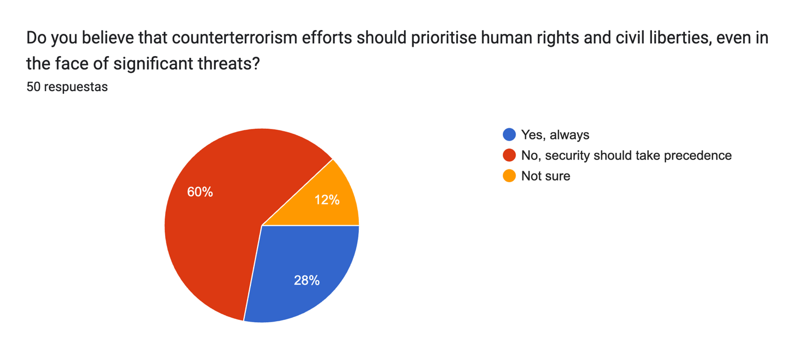

**Figure A2.** Killing of Innocent Civilians Justification

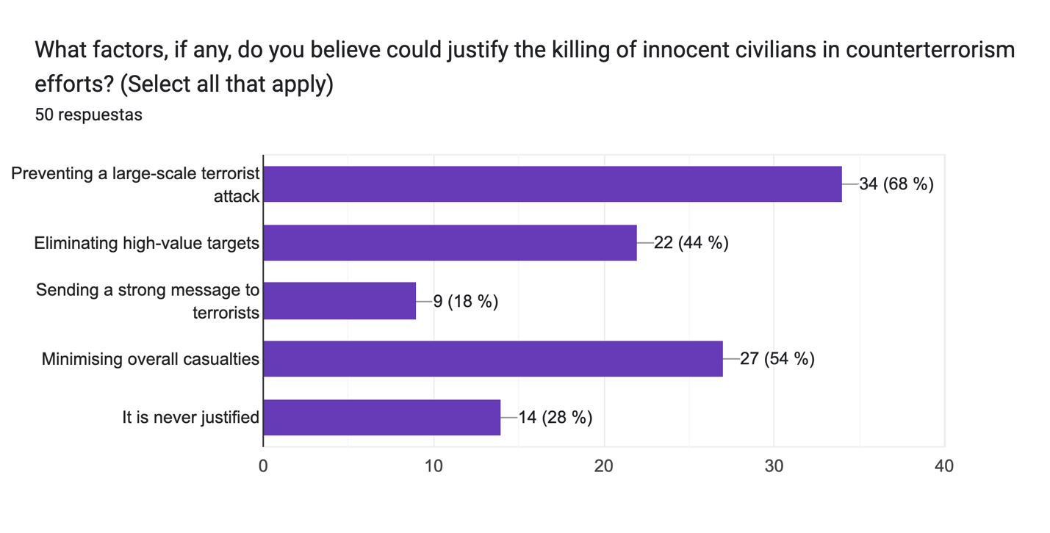

**Figure A3.** Preferable Approach Among Contestants.

Gráfico de respuestas de formularios. Título de la pregunta: In the specific context of counterterrorism, and considering the potential drawbacks of each approach, which type of government would you prefer and believe would provide greater safety: an authoritarian or a democratic one?
. Número de respuestas: 50 respuestas.

**Appendix B: Russia’s Correlation between democracy and Terrorism**

**Figure 6:** Electoral Democracy in Russia (1970-2020)

**Figure 5:** Terrorism Incidents in Russia (1970-2020)

